Contraceptive Suppositories OB-GYN 101 ©2003

Each suppository is individually wrapped and contains nonoxynol-9, a standard spermicide.
After opening the package, the suppository is pushed deeply into the vagina so that it lies against the cervix.
After insertion, the suppository needs 10 minutes to melt to form an effective spermicidal barrier. Once in place, it is effective for up to one hour after insertion. If additional intercourse is performed, an additional suppository should be inserted.
The suppository forms a spermicidal foam barrier within the vagina. It does not need to be removed as the foam will gradually discharge over the next few hours. Douching, if desired, should not occur during the first 6 hours after use, because some of the contraceptive protection may be lost.
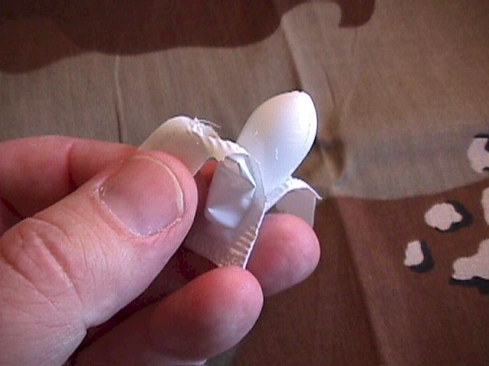
Because the active ingredient is nonoxynol-9, some individuals (up to 20% of the population) will be sensitive to it and experience a burning sensation during use. Those individuals should not continue to use this method of contraception and should seek another alternative.
Effectiveness of the vaginal suppository is similar to that of the diaphragm. If used carefully and consistently, about 5 women out of 100 will become pregnant each year, despite the use of contraceptive vaginal suppository. For the average user, failure rates are likely higher, about 15 or 20% each year.

