Labor OB-GYN 101 Facts Card ©2003 Brookside Press

Labor consists of regular, frequent, uterine contractions which lead to progressive dilatation of the cervix.
Braxton-Hicks contractions occur prior to the onset of labor. These innocent contractions can be painful, regular, and frequent, but usually are not.
The cause of labor is not known but may include both maternal and fetal factors.
The first stage of labor is that portion leading up to complete dilatation. The first stage can be divided functionally into two phases: the latent phase and the active phase.
Latent phase labor precedes the active phase of labor. Characteristics of women in latent phase labor:
- < 4 cm dilated.
- Regular, frequent contractions that may or may not be painful.
- Contractions wax and wane
- Dilate only very slowly
- Can talk or laugh during Ctx.
- Lasts hours to days.
Active phase labor shows rapid change in dilatation, effacement, and station.
Active phase labor lasts until the cervix is completely dilated:
- Are at least 4 cm dilated.
- Regular, frequent contractions are usually moderately painful.
- Progressive cervical dilatation of at least 1.2-1.5 cm per hour.
- Not talking or laughing during their contractions.
Progress of Labor
For a woman experiencing her first baby, labor usually lasts about 12-14 hours. If she has delivered a baby in the past, labor is generally quicker, lasting about 6-8 hours.
Dilatation and effacement occur for mechanical and biochemical reasons.
Descent means that the fetal head descends through the birth canal. The "station" of the fetal head describes how far it has descended through the birth canal.
This station is determined relative to the maternal ischial spines, bony prominences on each side of the maternal pelvic sidewalls.
"0 Station" ("Zero Station") means that the top of the fetal head has descended through the birth canal just to the level of the maternal ischial spines. +1 and -1 are cm above and below the spines.
There are five classical steps in the normal mechanism of labor. They are:
- Descent
- Flexion
- Internal Rotation
- Extension
- External Rotation
There are four basic pelvic shapes:
- Gynecoid
- Android
- Anthropoid
- Platypoid
A gynecoid pelvis is oval at the inlet, has a generous capacity and wide subpubic arch. This is the classical female pelvis.

Gynecoid
A platypoid pelvis is flattened at the inlet and has a prominent sacrum. The subpubic arch is generally wide but the ischial spines are prominent. This pelvis favors transverse presentations.

Platypoid
An android pelvis is more triangular in shape at the inlet, with a narrowed subpubic arch. Larger babies have difficulty traversing this pelvis as the normal areas for fetal rotation and extension are blocked by boney prominences. Smaller babies still squeeze through.

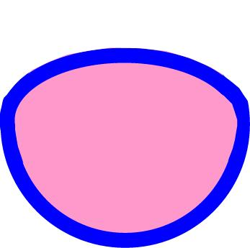
Android
An anthropoid pelvis is, like the gynecoid pelvis, basically oval at the inlet, but the long axis is oriented vertically rather than side to side.Subpubic arch may be slightly narrowed. This pelvis favors occiput posterior presentations.

Anthropoid

